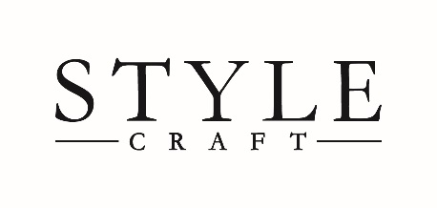
www.stylecraftonline.com

StyleCraft Home Collection | 8474 Market Place Dr. Suite 104 | Southaven, MS 38671
Phone 662.429.5279 | Fax 662.912.1008

CREDIT APPLICATION
EMAIL TO AR@STYLECRAFT-US.COM
PLEASE CHECK ONE

- CORPORATION
- PARTNERSHIP
- PROPRIETORSHIP

ENTITY LEGAL NAME TRADE NAME
|
BILLING ADDRESS

CITY STATE/ZIP PHONE NUMBER/FAX NUMBER
| |

ACCOUNTS PAYABLE CONTACT NAME ACCOUNTS PAYABLE EMAIL
|

SALES CONTACT EMAIL STATE INCORPORATED
|

CONTACT NAME CONTACT ADDRESS TELEPHONE NUMBER
| |

TRADE CREDIT REFERENCES

COMPANY NAME CITY/STATE/ZIP TELEPHONE NUMBER EMAIL OR FAX NUMBER | | | |

COMPANY NAME CITY/STATE/ZIP TELEPHONE NUMBER EMAIL OR FAX NUMBER | | | |

COMPANY NAME CITY/STATE/ZIP TELEPHONE NUMBER EMAIL OR FAX NUMBER | | | |

BANK REFERENCE

BANK NAME BANK OFFICER CITY/STATE/ZIP
| |
THE UNDERSIGNED WARRANTS THE INFORMATION GIVEN TO BE TRUE. STYLECRAFT HOME COLLECTIONS IS AUTHORIZED TO INVESTIGATE THE REFERENCES HEREIN, STATEMENTS OR OTHER DATA OBTAINED FROM MY COMPANY OR FROM ANY OTHER PERSON PERTAINING TO MY CREDIT AND FINANCIAL RESPONSIBLIITY.
ALL CHARGES ARE DUE AND PAYABLE BASED UPON TERMS ON INVOICE. A LATE PAYMENT CHARGE OF 1.5% PER MONTH PLUS ATTORNEY'S FEE, IF NECESSARY FOR COLLECTION, WILL BE ADDED TO ANY BALANCE NOT TIMELY PAID. A $25.00 FEE WILL BE ASSESSED FOR EACH NSF CHECK. I HAVE READ, UNDERSTAND AND AGREE TO THE ABOVE CONDITIONS.

BY [SIGNATURE] OFFICER TITLE DATE
| |
BY [PRINT] DATE
|

